~~SLIDESHOW~~

Progress Report Graduate School second Year
David Haberthür

Introduction
why do we do it (@TOMCAT)?
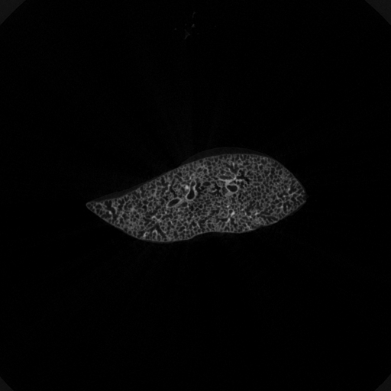microCT
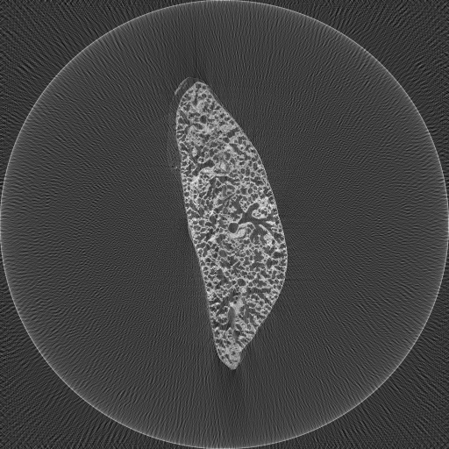TOMCAT
size: 1248 x 1248 vs. 8192 x 8192 px resolution: xx um vs. x um

Wide Field Scan
overlapping projections
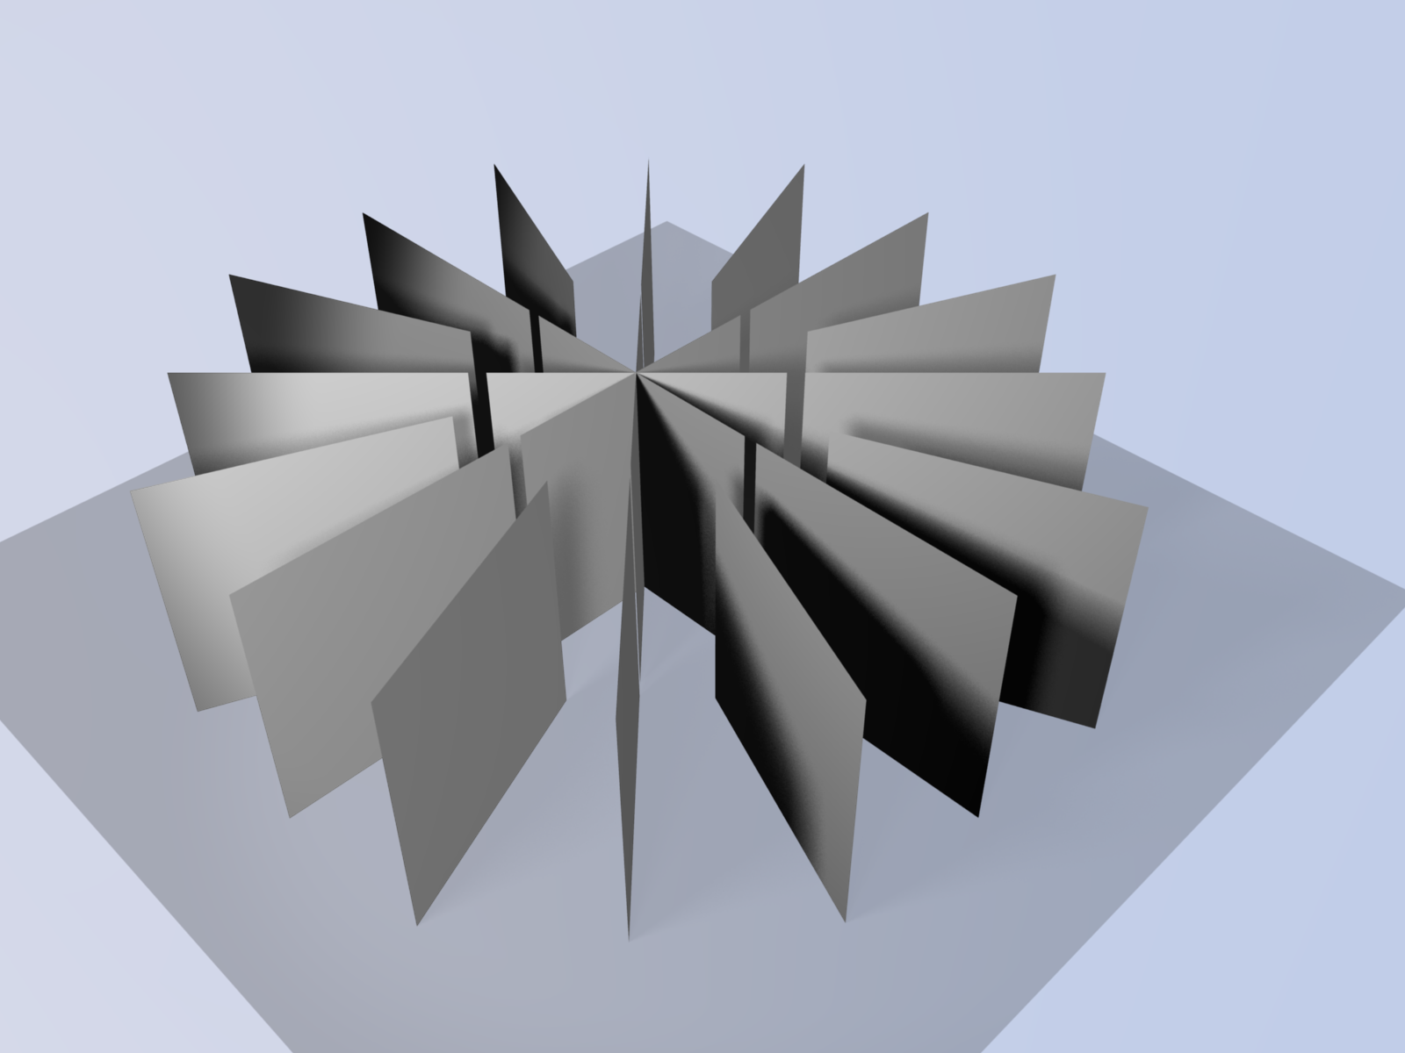
central and ring scan

Skeletonization
explain

