X-Server connection and configuration for Windows
The following steps show you how to install a (free) implementation of a working X-Server on Windows.

X Server
To work with GUIs on remote systems, you need a working X-Server on your windows system. On older windows systems, you can use the X Live CD. The X Live CD doesn't work on newer windows systems (including Windows 7), for those systems the easiest way to connect to remote *NIX servers is by installing the Xming X Server for Windows.
To do this, go to its sourceforge site and get at least “Xming-…-setup.exe”. Additionally, you can also download and install the “Xming-fonts-…-setup.exe”, which will install a set of fonts so everything will look nice.
When you start the X-Server after installation, you should have a little Xming icon in your tray (as shown here: ). This is all you need for this step.
xming tray icon

PuTTY
To actually connect to a remote server, PuTTY works wonderful.
Go to its download page, download the “Windows installer for everything except PuTTYtel” which is currently “putty-0.60-installer.exe”.
After installation and startup of PuTTY, you'll see its configuration window (shown below)
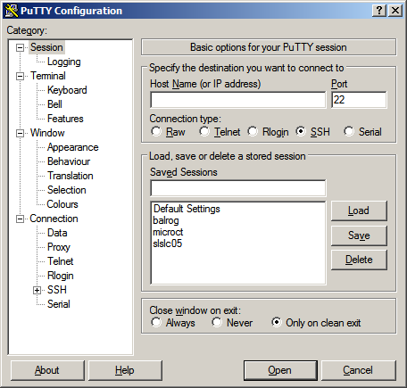putty configuration window
In this configuration window, you can add the correct IP or address of the computer you want to connect to. Then you NEED to enable X11 forwarding for the selected session. Then it's probably best to save the session, so you don't have to configure it from scratch every time you connect.
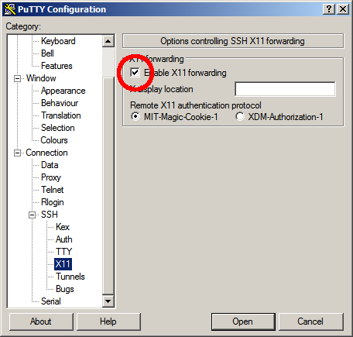

Result
The little screencast below shows the configuration and usage of the Xming/PuTTY-combination for our microCT from start to end:
So, to connect to and work on a remote system in future, you need to
- start Xming
- start PuTTY and connect to one of your saved sessions
- enter commands and stuff in the terminal window inside PuTTY

X-Server connection and configuration for Mac
Use the X11 terminal for SSH-Connections. X11 comes pre-installed on any newer Mac, if you don't have it, you can use the original Installation DVD or download a recent release from the X11 homepage.
If your connections actually need the X-Server, you need to use the flag “-X” in the SSH command, so start a connection by issuing
ssh -X haberthuer@slslc05.psi.ch
and the X Server will forward you any windows to your desktop.

X-Server connection and configuration for Linux
Why are you here? You already have everything under the hood. Just remember to use the “-X”-flag for the relevant connections.

