Remote Access

SSH: Working on the µ40 from remote
The machine can be accessed per ssh using
$ anatomie@dkf38-20.dkf.unibe.ch
If you're running an X-server (see the X Server-page for details), you can also start the MicroCT-Command-Window using the command:
$ uct
Sometimes the window doesn't open (at least on my windows-installation), either use the right mouse button on the taskbar to maximize it or use
$ uct_eval
in the console to start the evaluation program or
$ uct_3d
to start the 3D visualization program of SCANCO.

FTP: getting the Data off the µ40
The fastest variant for accessing and downloading the data-files is FTP.
To access the MicroCT, use
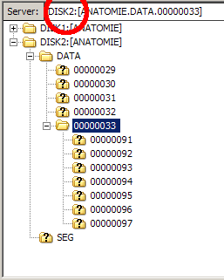MicroCT access in FileZilla
ftp://dkf38-20.dkf.unibe.ch
as a host name. The username is “anatomie” and the password is the same as for console access.
On windows, FileZilla has been shown to be the easiest solution to access the µ40. The only to keep in mind is that—since we have an external disk at the MicroCT—you must switch to this second disk in your FTP-program.
For FileZilla, you just enter DISK2 at the front of the server-path (as shown in the image on the right).

Web Access: access some Data from anywhere
Go to dkf38-20.dkf.unibe.ch/~anatomie and enter the login credentials, and you can access most of the data from anywhere.

